Celebrating Chinese New Year at the CIUC
Beginning of the Year of the Dragon, Sharing Joy Together

The Confucius Institute at the University of Colombo (CIUC) celebrated the Chinese Spring Festival on February 8, 2024 under the theme of "Beginning of the Year of the Dragon, Sharing Joy Together". The purpose of holding the event was to enhance the interest on Chinese culture and traditions as well as stimulate students' interest in learning Chinese among the staff and students of the Faculty of Arts.
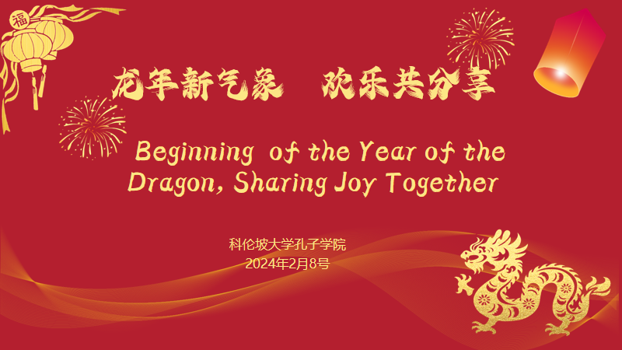

The staff activity was held at the Arts Faculty Boardroom, while the student activity was held at Classroom 128. Both activities were covered all aspects and affiliated traditions of the Chinese Spring festival
At the staff activity Professor Ma Zhongwu welcomed the staff members of the Faculty of Arts and introduced the origin and significance of the Chinese Spring Festival. He emphasized some customs of the Chinese New Year and its importance to Chinese people at large. Teacher Ms. Li Jingyi introduced the Chinese Spring Festival to everyone in a vivid way, allowing participants to have a deeper understanding of the traditional customs of the Chinese Spring Festival. Interactive sessions and tea breaks were also set up during the event, providing more opportunities for staff to communicate. Professor Anuththaradevi Widyalankara sent Spring Festival blessings to the attendees and made a concluding speech.

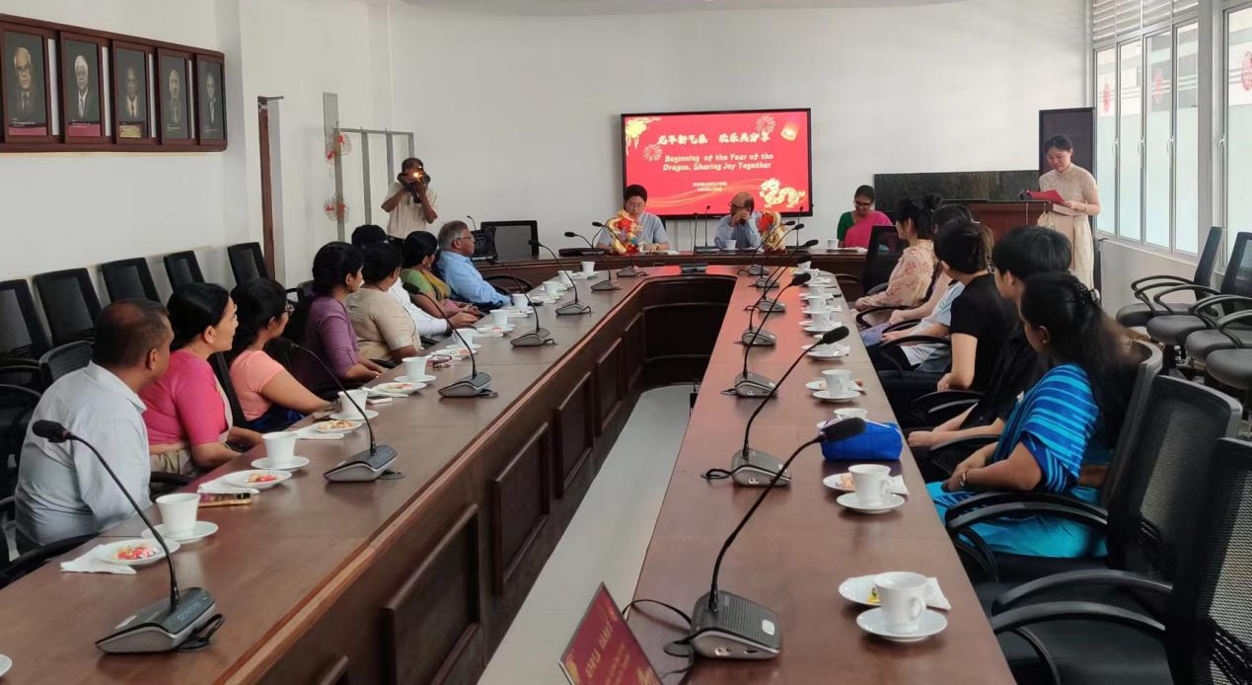

At the student activity teacher Ms. Li Jingyi introduced the origin, significance and various interesting customs of the Spring Festival. Students then participated in game sessions such as prize-winning quizzes and trapping good luck, which not only increased the interactivity, but also stimulated students' enthusiasm for participating in Chinese cultural activities. In addition, there were also activities such as hand-making, drawing "福" composed of dragon shape, and lottery draws facilitating students to feel the charm of traditional Chinese culture in joy.
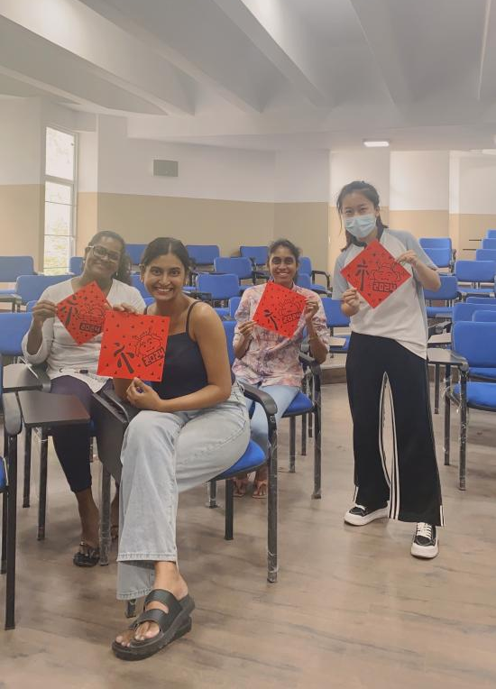
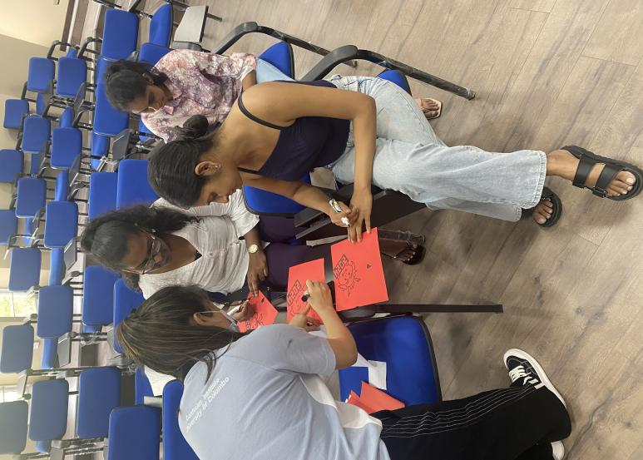

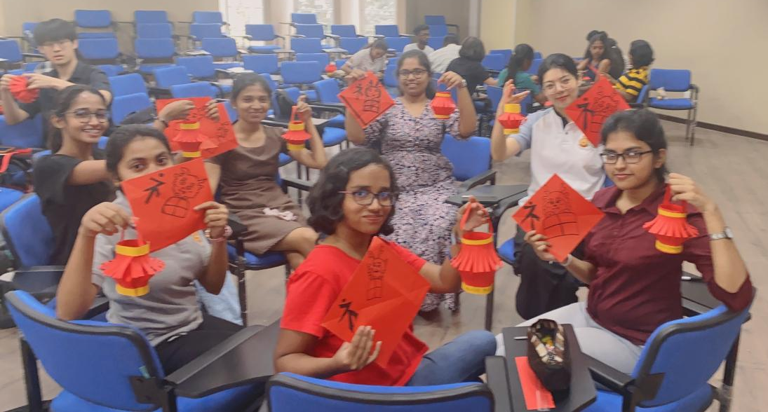

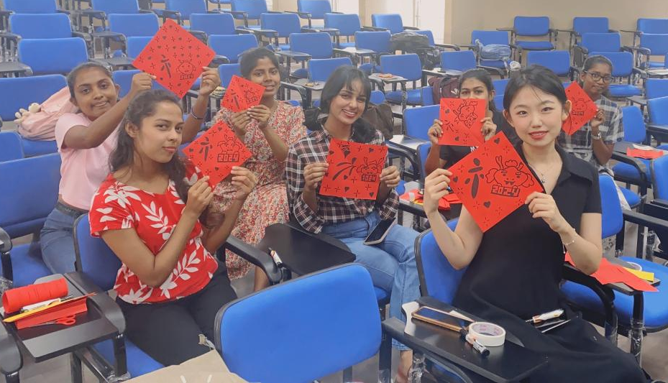

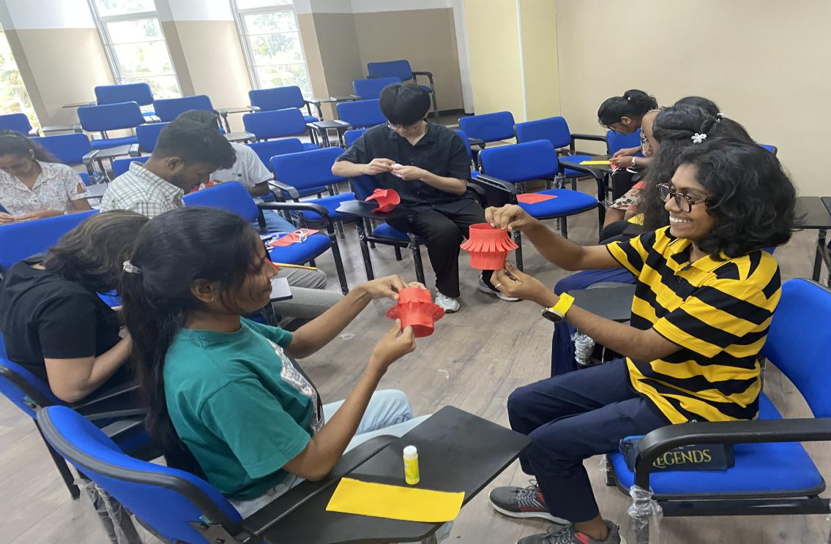

The successful holding of this Chinese Spring Festival cultural event not only enriched the cultural life of the campus, but also enhanced the mutual cultural understanding among teachers and students, while creating a strong festival atmosphere at the faculty.
